**Empowering Hospitality Healthcare Insights for Effective Emergency Care**

**Problem Statement:**

For an ABC Company enhancing Healthcare Insights through Emergency Care Data Visualization. In the ever-evolving healthcare landscape, the provision of effective emergency care services is vital for ensuring patient well-being and operational efficiency. Within ABC Company, understanding the demographics of patients visiting the Emergency Department (ED) holds significant importance for optimizing resource allocation and enhancing patient experiences.

The objective of this project is to harness data visualization techniques to analyze the number of patients by age visiting the ED, thereby deriving actionable insights to improve emergency care provision.

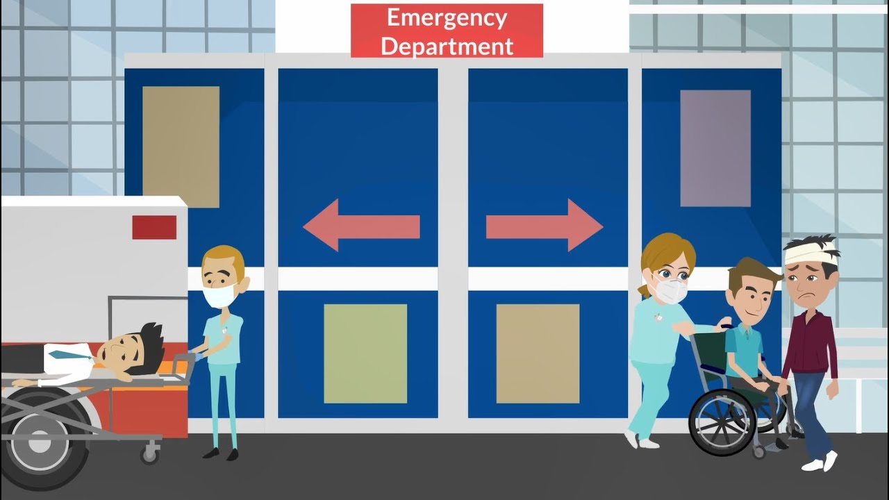

**Objective:**

An objective is a specific, measurable, and time-bound goal or target that an individual or organization aims to achieve. Objectives are typically set to guide actions and decision-making towards desired outcomes. They are often a part of broader goals and help to clarify what needs to be accomplished within a certain timeframe. Objectives should be realistic, achievable, and relevant to the overall mission or purpose, providing a clear direction for efforts and resources.

**Task:**

* Employ data visualization techniques to depict the age distribution of patients visiting the Emergency Department (ED), enabling a clear understanding of the demographic composition.
* Extract actionable insights from the visualized data to inform resource allocation, staffing adjustments, and patient-centric care strategies, aiming to optimize emergency care provision and enhance patient experiences effectively.

**Dataset**: [Link](https://data.world/markbradbourne/rwfd-real-world-fake-data)

**Solution Development Procedure:**

* Load the data into Tableau Desktop.

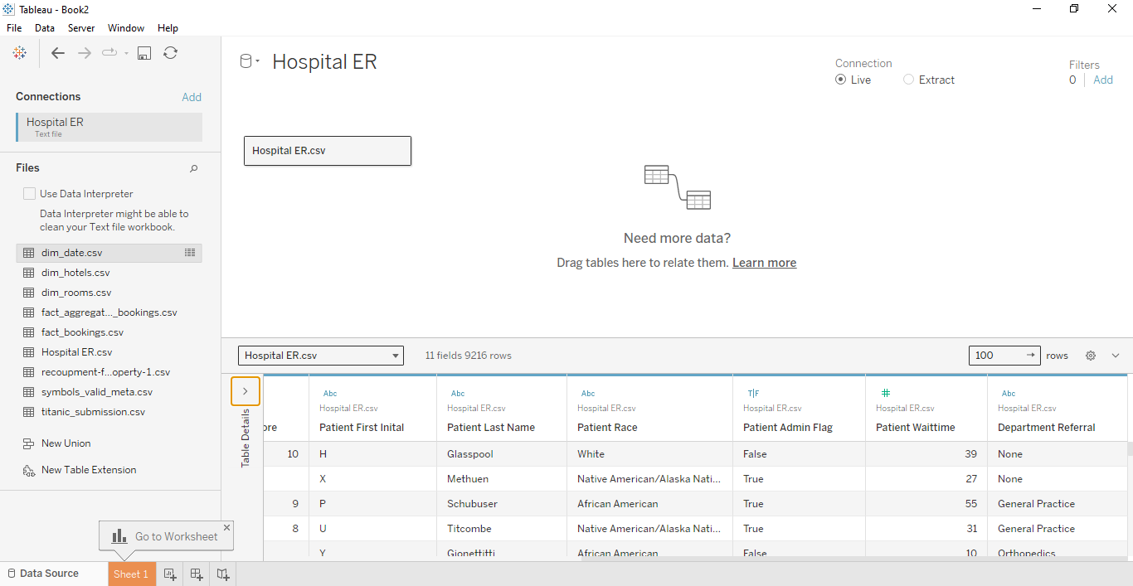

* Create a calculated Field and name it as Age Groupings .

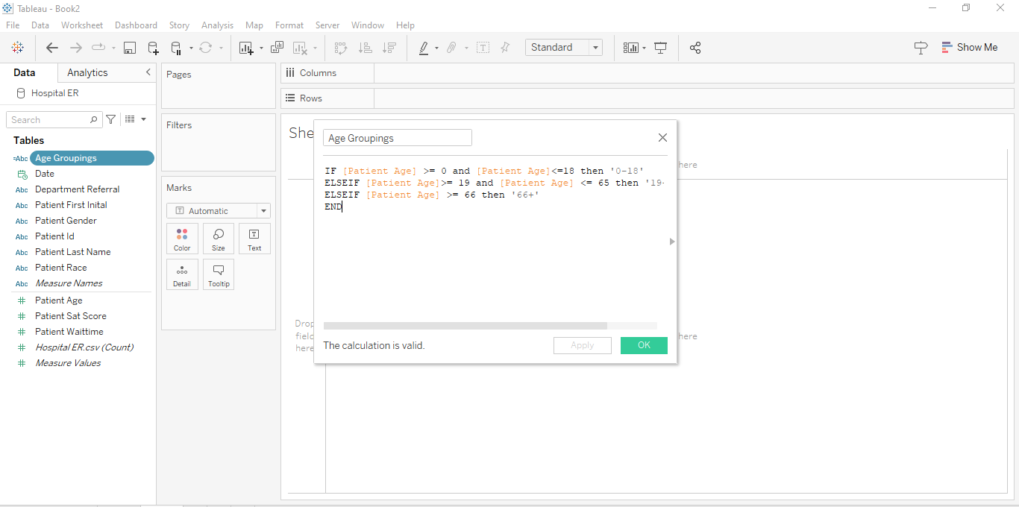

* Drag Date to Columns and Convert Year to Month(Date).

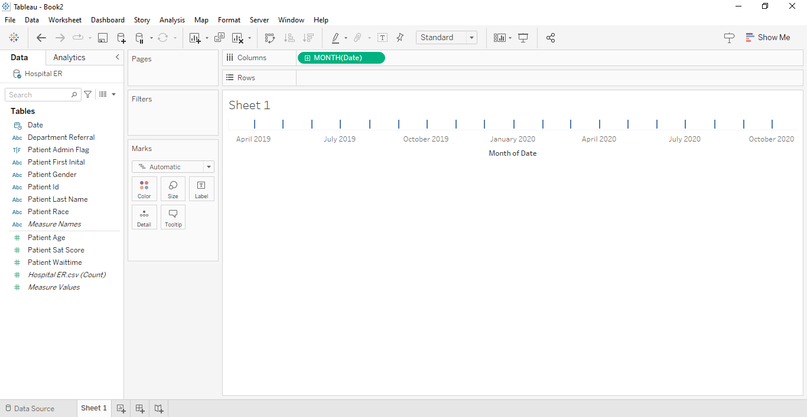

* Drag Patient Id into the Detail in Marks Card and Convert it into Count of Patient Id.

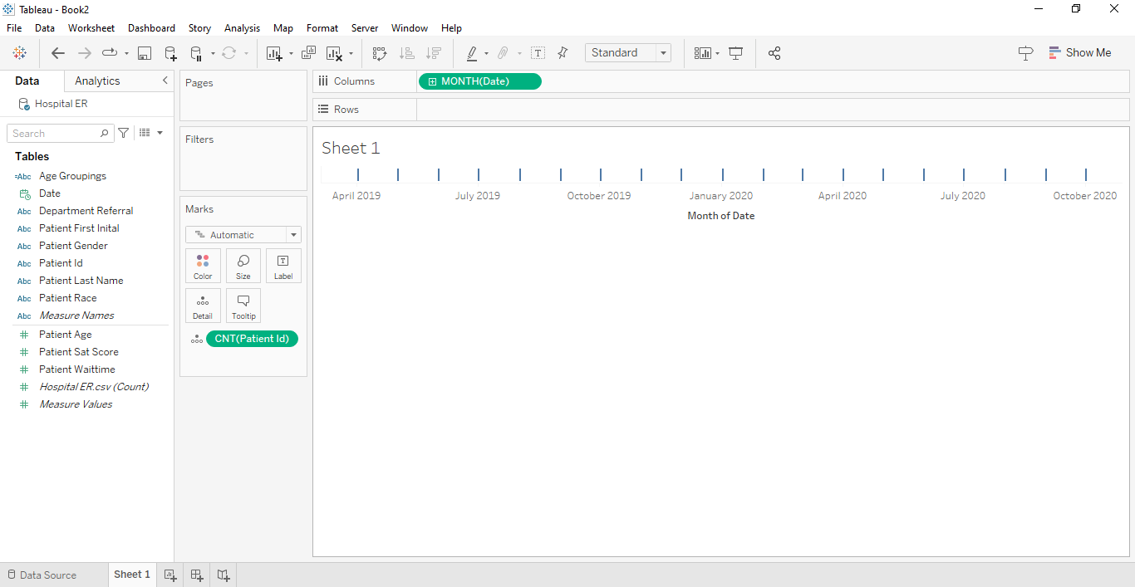

* Drag Count of Patient Id from Marks Card to Rows .

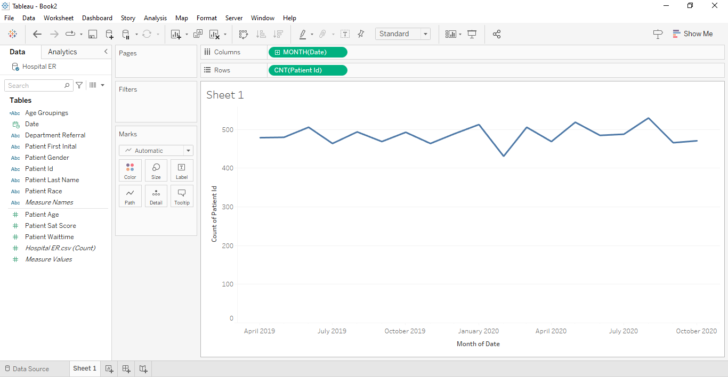

* In Marks Card Change from Automatic to Area Chart.

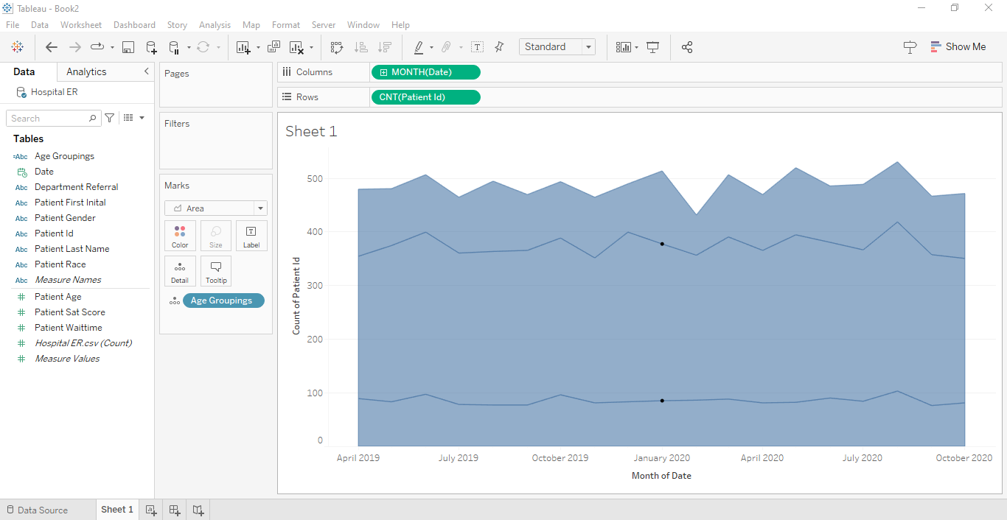

* To colour Area Chart , Drag Age Groupings to Colour in Marks Card.

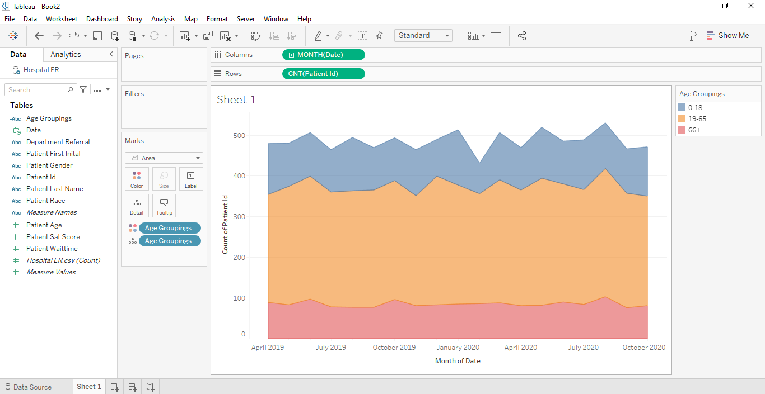

* To Indicate Ages on Area Chart, Drag again your Age groupings to Text in Marks Card.

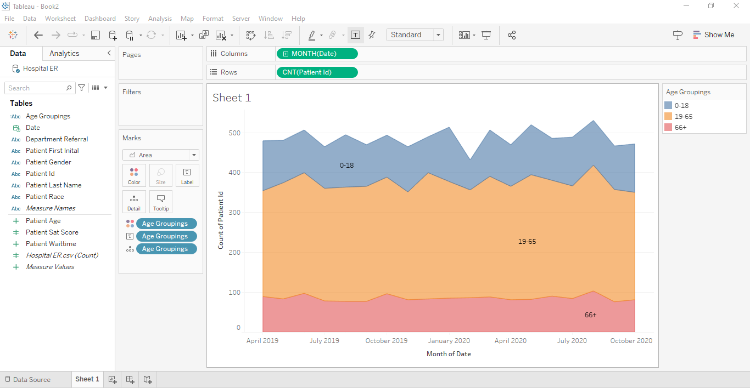

* Edit Axis on Area Chart and set the Title to None for X axis as well as for Y axis.

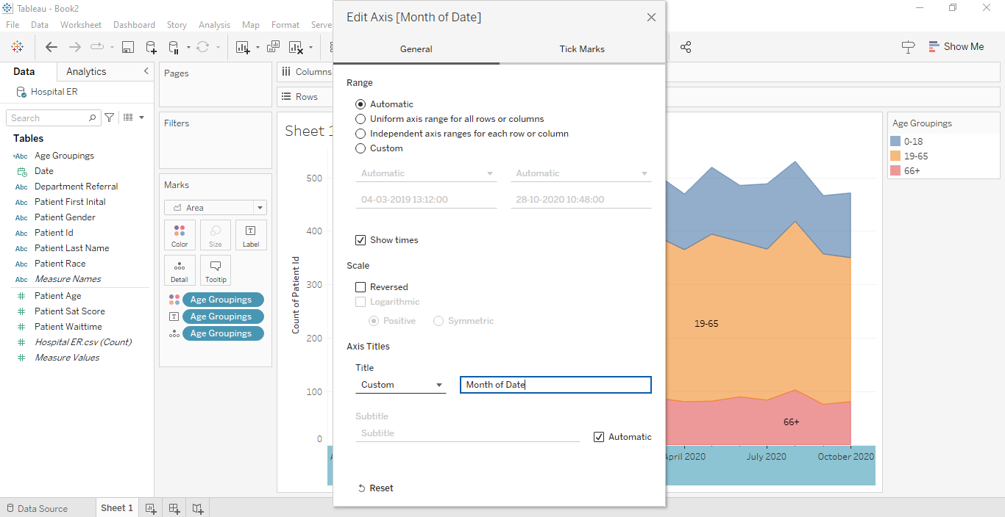

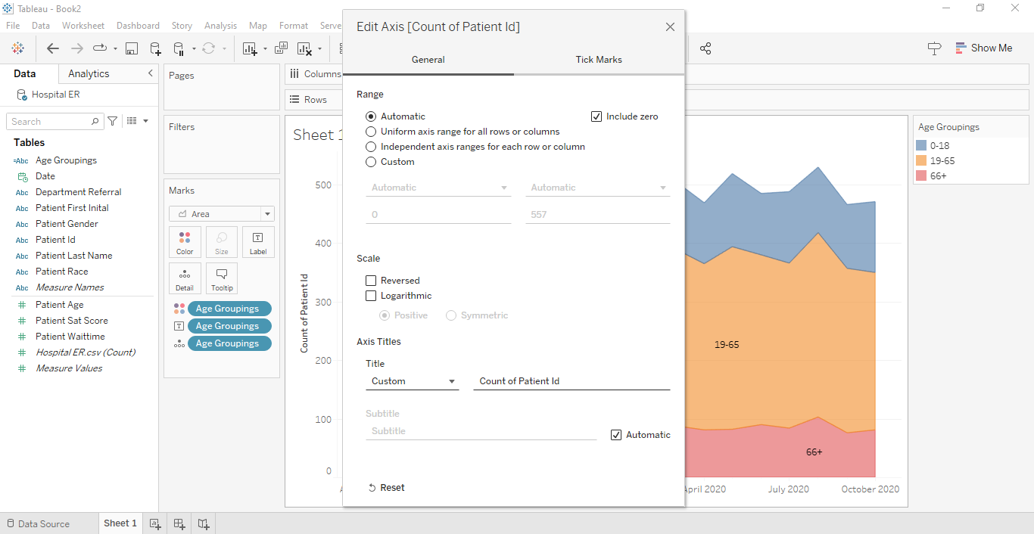

* Edit X axis and Format the Dates to MMM-YY.

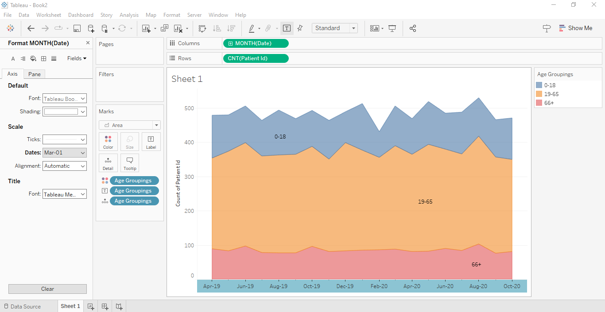

* Format your Shading and Borders and Age Grouping Colours and Change the Title.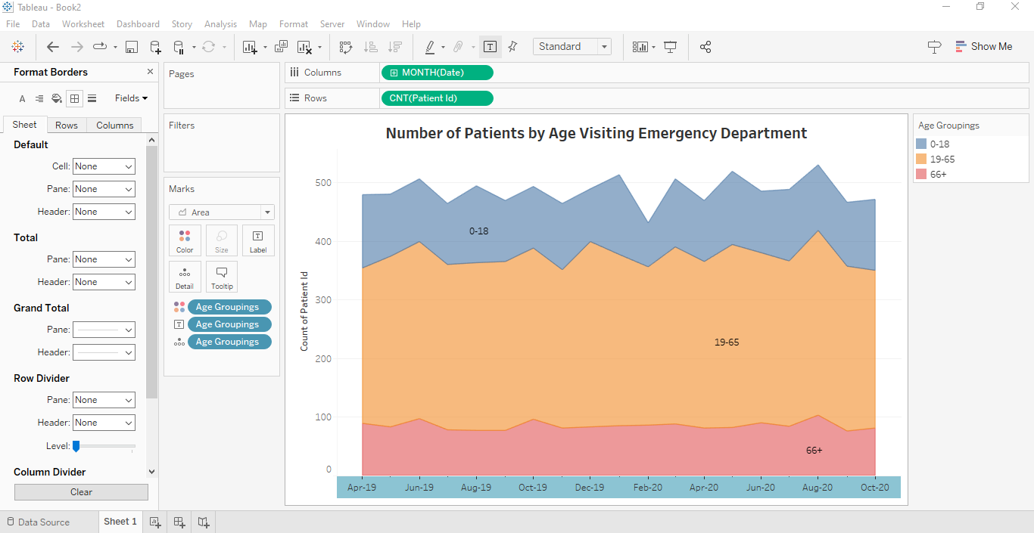

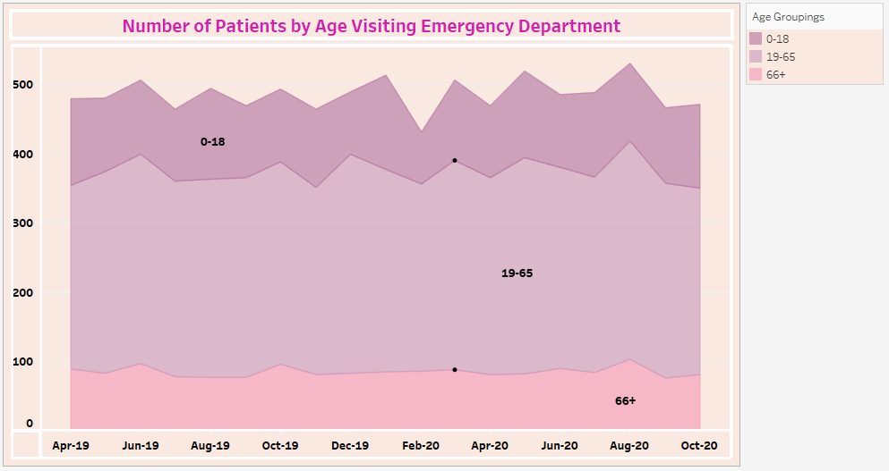

**Insights:**

Insights refer to valuable and meaningful understandings or perceptions gained from analyzing data, information, or experiences. They provide deeper understanding, clarity, or revelation regarding a particular subject or situation.

* The data visualization reveals that individuals aged 19-65 represent the largest proportion of patients visiting the Emergency Department, indicating a significant demographic in need of emergency care services. This insight suggests a potential focus for resource allocation and tailored care strategies to accommodate the specific needs of this age group effectively.
* Analysis of the visualized data indicates fluctuations in ED visitation patterns by age over time, with noticeable peaks during certain months or seasons. Understanding these temporal trends can inform staffing adjustments and resource allocation strategies to align with varying demand levels throughout the year, ensuring efficient and responsive emergency care provision.

**Conclusions :**

Conclusions are logical deductions or decisions drawn from observations, evidence, or analysis. Conclusions are often based on the findings or results of a study, experiment, or evaluation, and they aim to summarize key insights or outcomes. Effective conclusions should be supported by evidence, logical reasoning, and critical thinking, leading to well-informed decisions or actions.

* The observed temporal trends suggest varying levels of ED visitation throughout the years, indicating the need for seasonal adjustments in resource planning.
* The age distribution of patients visiting the ED provides valuable insights for developing patient-centric care strategies.